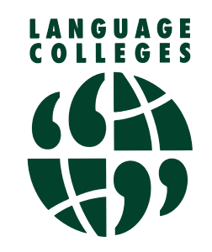
Alderman White School / White Hills Park Trust
Language College
Mr K Stephan – Director of Language College
Tel: 0115 9175944
https://aldermanwhite.school
languages@aldermanwhite.school
Chilwell Lane, Bramcote, Nottingham NG9 3DU

Registration Form
Saturday Classes - 2024 / 2025

Class/Language:
Time:
Surname:

First name:

Address:

Post code:
Telephone/Mobile number:

E-Mail Address:

How did you find out about the course?
(Please indicate) Attended last term, School Website, Roadside Banner, Friend Recommended, other:

Single class: £6.00 or *£7.00 per session (1 hr) *JLPT/ GCSE classes cost £6 per session (1 hr)
Multiple classes: £10.00 per week for individuals, £15.00 per week per family.
Lessons cost from £6.00 per session in a class of 6 + persons. Please refer to the programme for further details.
Some classes will be face-to face, others maybe be online or a mixture of the two. We operate a ‘Pay-as-you-
learn’ scheme with half termly payments (6 weeks) requested in advance by BACs or cheque. Payment is
required for all weeks unless a lesson is cancelled. Should the number drop below 6 people, we may have to
increase the cost per session. Payment is required for all weeks unless a lesson is cancelled. Please complete this
form in full referring to the GDPR Privacy Notice enclosed explaining why we collect and how we use this
information. If you have any questions please do not hesitate to contact us

I have read the above and accept the conditions relating to the course.

Signature:

